AS YOU HAVE DONE BEFORE, using the Powerpoint file called “CH17- Intro to Graphics”, and this worksheet, fill out the blanks. (copy and paste) from the chapter.

HIGHLIGHT YOUR ANSWERS THIS TIME IN PINK.
THIS IS WORTH TWO GRADES.

- The most common ways to create digital graphics are:

*-

*-

2- A _________________ _____________________ is created by using paths or lines.

3- A _________________ _____________________ is formed by a pattern of ___________.

4- Each single point in the image is a _________________.

5- What does the term “PIXEL” short for? ______________________ _____________________

Using your SNIPPING TOOL- “insert” below in the space provided the picture from the PowerPoint showing these two examples of graphics.

6- A ______________________ _______________________ allows you to create a new raster image.

7- A __________________ ______________________ allows you to create and edit vector images.

8- An advanced paint program is called an __________________ ___________________.

9- ____________ qualities affect how every raster image will appear.

10- Size, which is , the _________________ and _______________ of the graphic, , is normally measured either in ________________ or in ____________________.

11-___________________ tells how many ________________ are in a certain ______________ of an image.
EXPLORING THE APPLICATION WINDOW OF A BASIC GRAPHIC PROGRAM. ALL GRAPHIC PROGRAMS WILL BE DIFFERENT
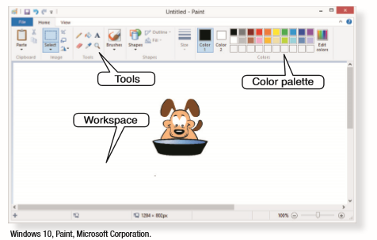

12- Most of the screen is devoted to the _______________, the blank, white area which contains the graphic.

13-A ____________________ is a bar across the top or down the side of a window that contains icons linked to the ______________ tools.

14-The display of color options in paint and draw programs is called the ________________ __________________ These options allow you to choose _______________ for an image.

EXPLORING THE APPLICATION WINDOW OF A BASIC PAINT PROGRAM. ALL GRAPHIC PROGRAMS WILL BE DIFFERENT

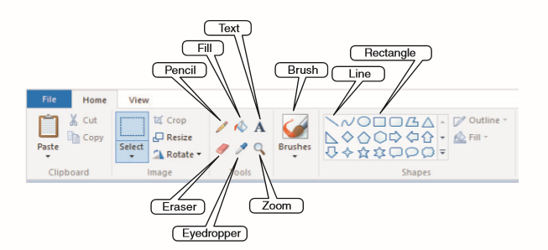

- The _____________ _________________ is used for _________________ drawing.

- The ___________________ __________________works like the Pencil tool, with a ___________________ stroke of color.

- The ______________ __________________ allows you to _____________a line.

- The ___________________ ___________________Eyedropper tool allows you to work
with a ___________________-color from an image.
- The ________________ ________________ removes color from an image.

- A _________________ ________________ allows you to select a portion of an image to be enlarged, moved, or edited.

- A variety of different _________________ _______________allow you to work easily with a graphics program.

- A ___________________ _______________________ is a piece of hardware used for _________________ or inking.

- A ___________________, or pointing device over the drawing surface creates on the screen the image that is being _______________ on the tablet.

- An effective graphic uses the basic principles of design, including __________________,__________________, and _____________________.

- _________________ uses differences in ________________ and ______________ to create a comparison.

- The way objects are arranged is called _____________________.

- The _________________and _______________ of one object in relation to other objects in the graphic is called ___________________.

- ______________________ in which a color, shape, or pattern is repeated throughout the graphic

- _____________________, which creates a focal point

- _____________________, in which the closeness between objects indicates a relationship

- ________________, in which objects in the image establish a connection through style or color

- ___________________, which is when the elements of the graphic come together as a complete idea

- __________________, which is the placement of text and objects so they line up within a space

- ________________, which creates visual interest by using different colors and shapes

- Many different elements are present in an effective graphic, including _____________ and ________________.

- The use of _____________ has a direct effect on the ___________________ of a graphic.

- Graphics are made up of many _________________, such as triangles and __________________.

- _________________ that create _______________, perspective, and shapes;

- ________________, which is the distance between _________________ in a graphic or on a page.

- __________________, which is the quality of the surface of shapes.

- Bringing information, such as a graphic, _____________ a file from another file is called __________________. (SOUND FAMILIAR??)

- _______________________ is when data is saved in a format that can be used in another ________________________. (SOUND FAMILIAR??)

- A powerful process known as __________________ , stacks each level of an image on top of another.

- _________________is the process of combining separate vector images into ________ image.

- __________________is the process of separating combined images into individual images.

- Instead of creating an image from scratch, you can start with _____________ __________, or graphics files that come with a program, or that you ________________ from the Internet.
LOOK AT THE EXAMPLES BELOW SHOWING DIFFERENCES FROM VECTOR CLIP ART AND RASTER CLIP ART. WHICH ONE IS CLEARER?

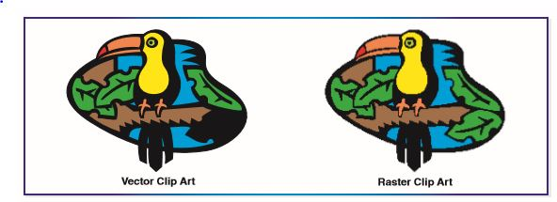

- If you want to use a graphic that is in a _______________ your program does not support, you may have to ________________ it.

- _______________ raster graphics to vectors requires a special process called _________________.

- Tracing requires special software and can be _______________ when an image has a lot of _______________ and __________.

