Spreadsheet basics—the beginning
Basics of Internet Worksheet-Find the answers in the PowerPoint presentation to fill in the blanks below.
Highlight your answers with the BLUE high lighter- MAKE THE TEXT BOLD

See example

- A __________________ is a program that processes information that is set up in tables.
- The parts of a worksheet include:
  - The ________________forms the top and left borders of the worksheet.
  - The ___________ ___________is the cell currently in use.
  - The cell ________________ is an area that shows the cell address of the cell that is active.
  - The ___________________ bar displays what you type.
  - ________________ bars allow you to see another part of the worksheet.
  - ________________ tabs switch between worksheets.
  - The ________________ bar shows messages from the program.
- When you use a ________________ program, your data goes into a special kind of document called a ____________, a grid made of vertical _________ and horizontal ___________.
- Each column and row meets to make a box called a _______l.
- Each cell in the grid is identified by a unique name—its _______ ______________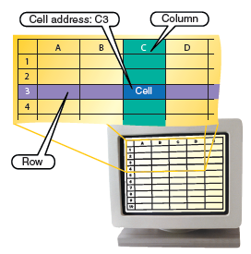.
- You can enter __________ types of data in a worksheet: ______________, __________, and __________ and times.
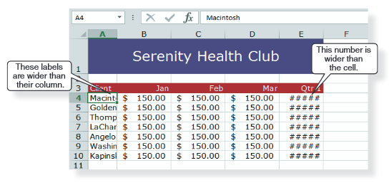
- A value is a ___________, such as a whole number, a _____________, or a decimal.
- A ___________ is text or a combination of numbers and text.
- ________________ are mathematical expressions. In a _________________, most formulas reference the data entered in one or more cells.
- You can change the _________ of a worksheet in many ways, including _____________ two or more cells which means combine them into one.
- ________________ are built-in formulas for performing calculations, such as ______________, in a table.
- With a spreadsheet program, you can create ____________, which are also called __________. Charts show data in ways that are visually more interesting and maybe easier to _______________.
- 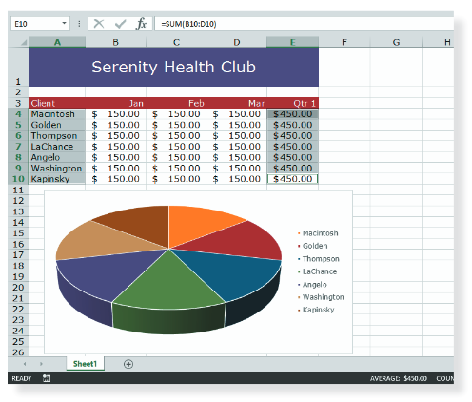
- You can specify a portion of a worksheet called a ___________ _____________ before you instruct the program to print. Then you can make sure the data displays the way you want.
- The order of evaluation rule tells the program to do the most important operation first, then it does the others in order, from most to least important.
- The ______________ of ____________ rule tells the program to do the most important operation _________, then it does the others in order, from ___________ to ____________ important.
- You can ___________ data to list rows ___________________ or __________________, and you can __________________ data to show only the rows that match the criteria you select.
- Formulas can use cell _________________, or cell addresses, to avoid errors and reflect _______________.
- With data that is too ______________ for a cell, symbols ____________ or ____________ appear in cells. With _____________, the text appears in the next cell to the _______________ or, if that is filled, is cut off.
- To indicate that numbers represent a dollar amount in a worksheet, you would type the numbers preceded by a _______________ _____________, or apply a currency type format.

